Ruined Chernobyl nuclear plant to remain a threat for 3,000 years
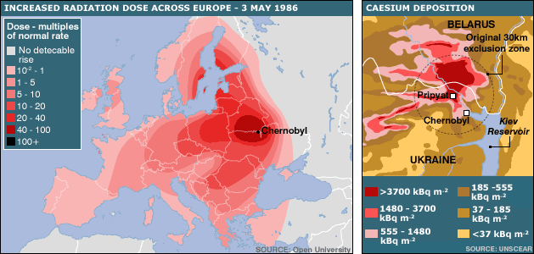

PRIPYAT, Ukraine — Before the fire, the vomiting, the deaths and the vanishing homes, the boys imagined bumper cars.
It was 30 years ago that Pripyat, a city in Ukraine, and the nearby Chernobyl power plant became known as the site of a nuclear disaster. Before the explosion, Chernobyl was just a little village in rural Ukraine. It was just a small spot in the Soviet Union.
Thirty years later, the full damage of that day is still argued. The Soviet Union is now known as Russia and its former Soviet republics are now independent states.
Anywhere from hundreds to millions of people died in the explosion. The numbers continue to vary. Today, the area near the reactor is both a lively wildlife refuge and a radiated ghost town. Much of Eastern and Central Europe continues to deal with fallout following the blast. Reactor Number 4, whose sudden increase in power led to the explosion, remains a problem that is neither solved nor solvable.

Bumper Car Dreams
The night before their world changed, nothing seemed more important to a group of 10-year-old boys than shiny blue and yellow cars. They dreamed of the bumper cars, with actual steering wheels, that they planned to drive the next week.
The bumper cars were to be turned on May 1, 1986. As the popular European holiday of May Day slowly approached, Alexandr Sirota and his friends could not resist sneaking down into the new park after dark. They stood beneath the shadows of the new Ferris wheel and looked at what would soon be the electrified roof over the bumper cars.
“We’d sit in the cars and make car noises,” recalls Sirota, who is now 40. “It was everything we could imagine wanting in life at that time. As young boys, our lives seemed perfect.”
Bumper cars. This is what Sirota thought about before he went to bed on April 25, 1986, and what he continued to think about after he woke on April 26 and rushed off to School No. 1.
As he slept, his world was changing.

Reactor Number 4 Blows Its Roof
Sometime after 1 a.m., the engineers who had spent the previous 24 hours putting Reactor Number 4 through a test were getting nervous. They wanted to see how it would handle a shutdown in electricity and then switch to an emergency power supply.
Thirty years later, nuclear scientists still do not agree on what went wrong. Nuclear plants create energy by splitting uranium atoms and setting off a nuclear reaction. At Chernobyl, the reaction got out of hand. Engineers tried to slow the nuclear reaction by inserting control rods into the center of the reactor. Instead, the reaction sped up.
In a matter of seconds, the temperature inside the reactor increased by 3,000 degrees. The water used to cool the uranium suddenly evaporated. In the sealed environment of the reactor the steam had no place to expand. That’s when the roof blew off, and an estimated 10 tons of the reactor’s 200 tons of enriched uranium blasted into the sky

"It Was A Horrible Mistake"
On April 26, 1986, Georgi Kopchinsky was a director of the Soviet central committee on nuclear energy. Today he still wrings his hands nervously as he talks about Chernobyl. He admits it is a very tough topic for him. This is in part because he says scientists should have known it could happen.
Three years before Chernobyl, he says, Soviet authorities had warned that a similar problem had been detected at other plants with the same kind of controlling devices. But no modifications were made.
“This was our arrogance at the time,” Kopchinsky says. “We believed we were the masters of the atomic reactions. It was a horrible mistake.”
After the roof blew, the walls collapsed and the superheated uranium melted and consumed all that fell into it. All that remained to protect the world from a 2,000-ton radioactive mass that was forming was the reinforced concrete foundation and four relatively thin walls. Above was only the open sky

In The Year 4986
The 10 tons of radioactive waste that flew into the air spread out in all directions over northern, eastern and central Europe. A scientific report by the European Parliament later estimated that Chernobyl radiation contaminated 40 percent of Europe.
It is difficult to imagine how long Ukrainian authorities must remain on guard. Estimates suggest the Chernobyl area will not be safe again until the year 4986. A similar span of time would stretch from when King David ruled Israel and before the founding of Rome to now.
Tetiana Verbytska is an energy policy expert at the National Ecological Center of Ukraine. She believes most people do not understand how challenging the history of Chernobyl is. There is a movement, she notes with concern, to shrink the radius of the no man’s land that surrounds the plant from 18 miles to six. She warns there is no solution.
“We don’t have the technology to fix the problem,” she said. “We don’t have the process to develop the technology to fix the problem, and we don’t have the money to support the process to develop the technology to fix the problem. The solutions for our Chernobyl problems are very much ‘seal it for now.’ We willhave smart children and smart grandchildren who in 100 years or so will figure out what to do.”
- According to the article, what happened at Chernobyl?

- Why does Georgi Kpchinsky feels bad talking about Chernobyl?

- According to the article, with which of the following would Tetiana Verbytska be MOST likely to agree?
(A) It is OK that we have not fixed the problem yet, because someday our children or grandchildren will figure it out.
(B) This problem is so difficult to solve that we cannot solve it with smart people alone. We need a great deal of money and new technology to help.
(C) Even if we had all the money and technology in the world, there would be nothing we could do to deal with the impossible disaster at Chernobyl.
(D) Even though the Chernobyl disaster is a very tricky problem, I have full confidence in our scientists and our government leaders to figure out this problem in the next few years.

