Palestinian-Israeli Conflict: A Webquest
Step 1: Visit this website: http://www.jewishvirtuallibrary.org/jsource/Zionism/herzlex.html
Read the excerpt and answer the question below.
- According to Theodor Herzl, why Jews need their own state? Summarize his points in 2-3 sentences.

This idea is what initially started the Palestinian-Israeli conflict.

Step 2: Visit this website: http://www.cfr.org/publication/13850/ (you may skip the intro)
Select Chapter 1: A Timeline. Navigate the timeline by clicking on the time periods on the bottom of the screen, beginning with the Mandate Period and ending with Diplomacy and Radicalization. Answer the following questions.
The Mandate Period
1914-1918: WWI: Seeds of the Conflict
- How did Britain’s actions contribute to the Palestinian-Israeli conflict during these years?

1929-1939: Jewish Violence, Arab Revolt
- What seems to be the initial cause of the violence during this period?

1937: Peel Commission
- What is the proposed solution to the conflict at this point in time?

1939-1945: World War II and the Holocaust
- List 2 ways that WWII affected the conflict.
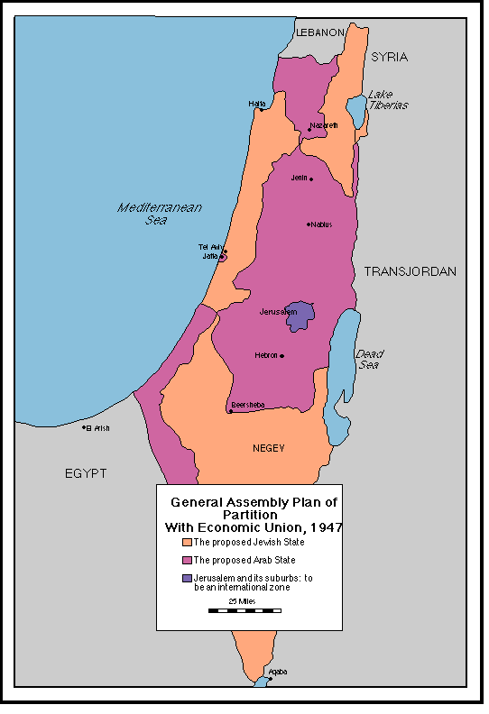
The Arab-Israeli Wars
1947-1948: Partition and War (Consider map to the right)
- Why did the Arabs object to Resolution 181?

- What 2 significant events follow the British evacuation in 1948?

- What has happened by the end of this short war?

1964: Founding of the PLO

- What is the PLO’s official argument of why Israel should not exist as a nation for the Jews?

June 1967: Arab-Israeli War
- What was the result of this short war?

September 1967: The “Three No’s”
- At this time, what is the Arab stance to the Nation of Israel? (Hint: 3 no’s!)

Diplomacy and Intifada
Read a sampling of the events during this time period. Then, answer the following question.
- How have the actions of the PLO extremists hurt the overall mission of the PLO? (Hint: consider what they have been labeled as)

Diplomacy and Radicalization
September 1995: Oslo II
- Even though it seems as if peace is attainable, what happens after this peace agreement is signed?

April 2003: Road Map for Peace
- President Bush outlines in his speech a compromise for peace. What does he call for?

January 2009: War in Gaza
- Currently, has the situation been resolved?

Step 3: Visit this website: http://news.bbc.co.uk/hi/english/static/in_depth/middle_east/2000/voices_of_conflict/default.stm
Read 1 entry from a Palestinian point of view and 1 entry from the Israeli point of view.
Palestinian point of view: ____________________________________________________________
Israeli point of view: ____________________________________________________________
- Write 1 thing the two accounts seem to have in common.

- Write 1 thing that seems to be unique to the Palestinian experience.

- Write 1 thing that seems to be unique to the Israeli experience.

